FORWARD & INVERSE KINEMATICS SOLUTION OF 6-DOF ROBOTS THOSE HAVE OFFSET & SPHERICAL WRISTS (KUKA ROBOT)

Abstract
This research presents a comprehensive, analytical solution for the forward and inverse kinematics of a 6-DOF industrial robot, specifically focusing on a common configuration that includes both joint offsets and a spherical wrist. The forward kinematics solution is established using the standard Denavit-Hartenberg (DH) convention. For the inverse kinematics, a geometric solution is employed, which is chosen for its intuitive and interpretable nature. This method uses kinematic decoupling, solving the problem by dividing the manipulator into two 3-DOF mechanisms: the first three joints for positioning the wrist center, and the final three spherical wrist joints for orientation.
The primary objective of this article is to provide a clear, step-by-step derivation that can serve as a solid foundation for future studies. A key contribution, which differentiates this work from many others, is the inclusion of interactive calculation tables and supplementary sheets. These tools are provided to confirm, verify, and make complex calculations accessible, overcoming the common difficulties associated with adapting code-based solutions.

Introduction

Industrial robotic manipulators are a critical component in modern automation, with 6-DOF (Degrees of Freedom) serial-chain arms, such as those from KUKA, representing common and versatile morphology. The effective implementation of any control system, motion planner, or simulation for these robots is fundamentally dependent on a precise and computationally efficient kinematic model. Kinematics, the description of motion without consideration of the forces and torques that cause it, provides the essential mapping between the robot's configuration in joint space and the pose of its end-effector in the operational task-space.
This paper presents the complete forward and inverse kinematic analysis of a custom-designed 6-DOF manipulator. The objective is to derive a robust mathematical model that serves as the foundation for future control and trajectory planning tasks.
The analysis is performed in a sequential manner. First, the robot's structure is parameterized using the Standard Denavit-Hartenberg (DH) convention. This process involves the systematic assignment of coordinate frames to each of the robot's six joints to derive a concise set of parameters $(a,i,θ,α)$ that define the manipulator's geometry.
Second, these DH parameters are used to solve the Forward Kinematics (FK) problem. By developing the homogeneous transformation matrices for each link, the composite transformation from the robot's base frame to the end-effector frame is formulated. This allows for the direct computation of the end-effector's position and orientation for any given set of joint angles.
Finally, the Inverse Kinematics (IK) problem is addressed. This involves determining the set of joint angles $(q_{1} ...q_{2})$ required to position the end-effector at a specific, desired pose (position and orientation) in its workspace.
1. Algebraic Solution
Solves the non-linear equations from the forward kinematics transformation $T_{n}^{0}(q)=T_{desired}$.
- Advantages: Robust and efficient for real-time use when a closed-form solution exists; independent of the DH convention; effective for simple manipulators (≤3 DOF).
- Limitations: Poor scalability—complexity grows exponentially with DOF and link offsets, making it impractical for most 6-DOF manipulators.
2. Geometric Solution
Decomposes the manipulator’s geometry into 2D trigonometric problems using the DH convention.
- Advantages: Fast and deterministic; widely used for 6-DOF manipulators (especially with spherical wrists); compatible with standard DH modeling.
- Limitations: Produces multiple valid solutions (e.g., elbow-up/down); must handle kinematic singularities where DOFs are lost.
3. Quaternion Solution
Uses 4D quaternions to represent and solve rotations.
- Advantages: Compact formulation; avoids gimbal lock; fewer equations.
- Limitations: Mathematically less intuitive; mainly suited for rotational systems; results less physically interpretable.
The resulting kinematic model provides the necessary foundation for all higher-level tasks, including singularity analysis, trajectory planning, and the future development of dynamic controllers for the manipulator.
Given that the kinematic structure under study involves rotational motion for each degree of freedom (DOF), employing a quaternion-based formulation would provide the most mathematically robust representation. However, for the purposes of clarity and intuitive understanding, this paper adopts a geometric solution approach. Although the robot joints exist in three-dimensional space, they are projected onto a single plane to simplify the analytical process. The spatial separations between consecutive joints are referred to as offsets. The exampled manipulator features two such offsets: one located between the first and second joints, and another between the third and fourth joints.
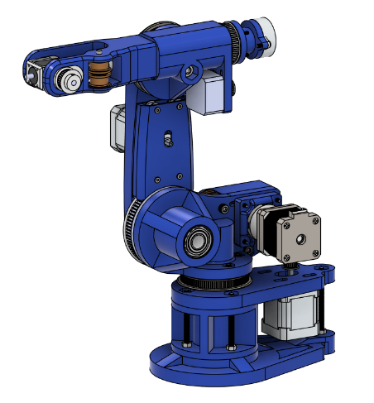
Figure 1. An example robot CAD model
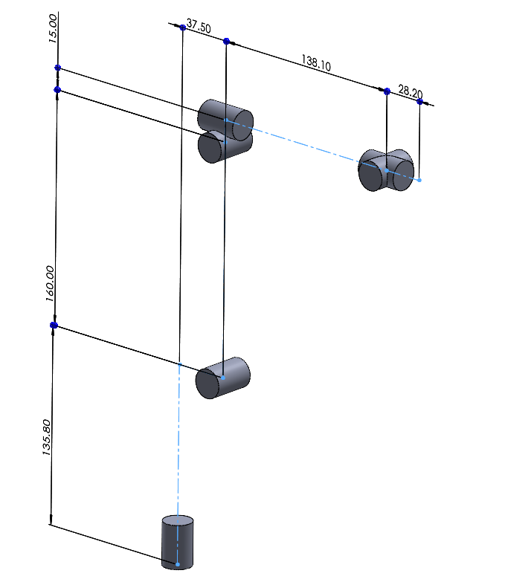
The fourth, fifth, and sixth joints collectively constitute a spherical wrist configuration. Accordingly, the six-degree-of-freedom (6-DOF) manipulator is decomposed into two subsystems: the first comprising joints one through three, and the second encompassing the spherical wrist assembly. It is important to note that the inverse kinematics (IK) of such systems inherently yield multiple possible joint configurations for a given end-effector pose. This phenomenon has been extensively addressed in prior research. In this study, only a single representative solution is presented—specifically, the one that provides the broadest and most continuous range of motion across the manipulator’s workspace.

Figure 2. Schematic of robot shown at Figure 1

ROBOT VARIABLES, PARAMETERS & DENAVIT HARTENBERG TABLE
A very commonly used 6-DOF robot has the following variables, parameters, parameters and corresponding Denavit-Hartenberg (DH) table. In this section, these known and unknown will be exposed using the schematics in previous section.

Variables
The 6-DOF robot manipulator consists of six revolute joints, each providing one rotational degree of freedom. By adjusting the rotation of these joints, the robot can position its end-effector to perform the desired tasks. The primary kinematic variables of the system are the six revolute joint angles, denoted as θ. At the home position, all joint angles are defined as 0°, and during operation each angle must remain within the range of −180° to +180°.
Through this paper and its supplementary materials, the following notation is used:

Subscript | Description
$$θ$$ | Joint angle
$$n = 1…6$$ | Indicates the joint number, counted from the base (joint 1) to the end-effector (joint 6)
$$v$$ | Variable joint angle (active rotation from home position)
$$h$$ | Home offset angle at the home position
$$f$$ | Joint angle used in forward kinematics (includes both variable and home offset components)
$$i$$ | Joint angle used in inverse kinematics (includes both variable and home offset components)
Table 1: Table of Subscripts
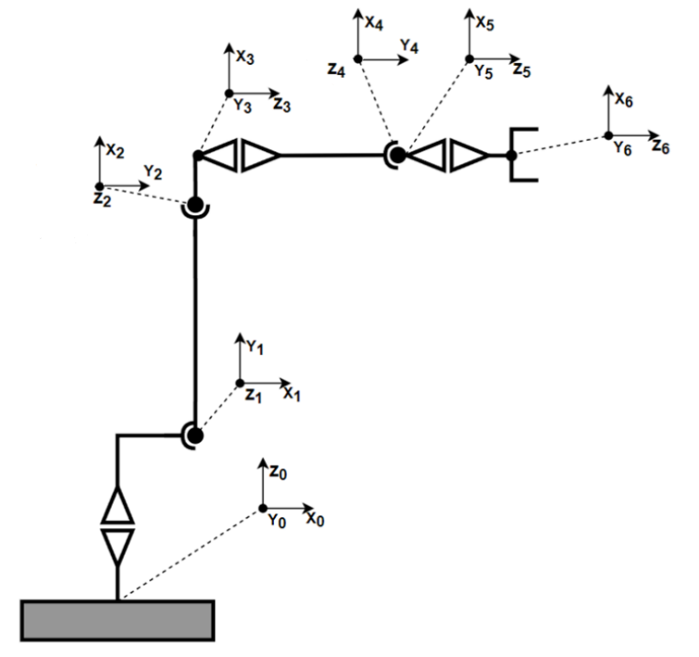

Figure 3: 2D Representation of schematics on Figure 2

Parameters & Denavit-Hartenberg Table
For the specified home position illustrated in Figures 2 and 3, the robot’s geometry is defined using the Denavit–Hartenberg (DH) convention. In this representation, each link and joint of the 6-DOF manipulator is described by four parameters: joint angle (θ), link twist (α), link offset (d), and link length (a). Each row of the DH table corresponds to one joint, resulting in a 6×4 table that fully characterizes the manipulator’s kinematic chain.
The definitions of the DH parameters are as follows:
- θ — Angle about the previous Z-axis, measured from the old X-axis to the new X-axis.
- α — Angle about the new X-axis, measured from the old Z-axis to the new Z-axis.
- d — Offset distance along the previous Z-axis, from the old joint to the new joint center.
- a — Length along the new X-axis, from the old joint to the new joint center.
When assigning local coordinate frames, the following conventions are applied:
- The Z-axis coincides with the joint axis — rotational for revolute joints or translational for prismatic joints.
- The X-axis is chosen to be perpendicular to both the previous and current Z-axes, intersecting them when possible.
- The Y-axis is determined according to the right-hand rule based on the orientations of the X and Z axes.
By following these conventions and using the geometric constraints illustrated in Figures 2 and 3, the complete DH parameter set of the robot manipulator (summarized in Table 1) can be derived. Proper placement and orientation of the local coordinate frames are critical steps in constructing the DH table, as they directly affect the simplicity and clarity of the kinematic model.

$$i$$ | $$θ$$ | $$d$$ | $$a$$ | $$α$$
$$1$$ | $$θ 1$$ | $$d1$$ | $$a1$$ | $$90°$$
$$2$$ | $$θ 2+90°$$ | $$0$$ | $$a2$$ | $$-180°$$
$$3$$ | $$θ 3$$ | $$0$$ | $$a3$$ | $$-90°$$
$$4$$ | $$θ 4$$ | $$d2$$ | $$0$$ | $$90°$$
$$5$$ | $$θ 5$$ | $$0$$ | $$0$$ | $$-90°$$
$$6$$ | $$θ 6$$ | $$d3$$ | $$0$$ | $$0°$$
Table 2: D-H Parameters of robot manipulator that’s schematics shown in Figure 2&3

In summary, the forward kinematics of the manipulator are determined by treating each joint’s rotation angle as a variable. Since every joint is characterized by four Denavit–Hartenberg (DH) parameters, a 6-DOF robot has six joint variables and a total of 6×4 = 24 DH parameters that collectively define the end-effector’s position in Cartesian space (x, y, z) and its three orientation angles.
For forward kinematics analysis, these six joint variables always remain the fundamental unknowns, regardless of whether the mechanism has 2, 3, or 10 degrees of freedom. Increasing the number of DOF has minimal impact on the forward kinematics process; however, the same cannot be said for inverse kinematics. As the number of joints and their configurations increase, the complexity of solving the inverse kinematics problem also grows, and certain analytical methods may no longer be applicable.

FORWARD KINEMATICS CALCULATION
In 1955, Denavit and Hartenberg introduced a matrix-based approach for systematically assigning coordinate frames to each link in a robotic manipulator. This method enables the precise description of both translational and rotational relationships between consecutive links. The kinematic model of the robot in this study is formulated according to the Denavit–Hartenberg (D-H) convention. The transformation between any two successive joints can be expressed by substituting the corresponding D-H parameters from the table into the transformation matrix, denoted as $Aₙ$, where:

$$A_{nf}= \left[\begin{matrix}\cos{θ_{nf}} & -\sin{θ_{nf}}cos{α_{nf}} & \sin{θ_{nf}}\sin{α_{nf}} & a_{nf}\cos{θ_{nf}} \\ \sin{θ_{nf}} & \cos{θ_{nf}}\cos{α_{nf}} & \cos{θ_{nf}}\sin{α_{nf}} & a_{nf}\sin{θ_{nf}} \\ 0 & \sin{α_{nf}} & \cos{α_{nf}} & d_{nf} \\ 0 & 0 & 0 & 1\end{matrix}\right]$$

When known joint parameters are put into their corresponding place in this matrix, then the following matrices are obtained for each joint starting from the base (1) to the tip (6);
$$A_{1f}= \left[\begin{matrix}\cos{θ_{1f}} & 0 & \sin{θ_{1f}} & a_{1f}\cos{θ_{1f}} \\ \sin{θ_{1f}} & 0 & -cos{θ_{1f}} & a_{1f}\sin{θ_{1f}} \\ 0 & 1 & 0 & d_{1} \\ 0 & 0 & 0 & 1\end{matrix}\right]$$
$$A_{2f}= \left[\begin{matrix}-sin{θ_{2f}} & \cos{θ_{2f}} & 0 & -a_{2f}\cos{θ_{2f}} \\ \cos{θ_{2f}} & \sin{θ_{2f}} & 0 & a_{2f}\sin{θ_{2f}} \\ 0 & 0 & -1 & 0 \\ 0 & 0 & 0 & 1\end{matrix}\right]$$
$$A_{3f}= \left[\begin{matrix}\cos{θ_{3f}} & 0 & -sin{θ_{3f}} & a_{3f}\cos{θ_{3f}} \\ \sin{θ_{3f}} & 0 & \cos{θ_{3f}} & a_{3f}\sin{θ_{3f}} \\ 0 & -1 & 0 & 0 \\ 0 & 0 & 0 & 1\end{matrix}\right]$$
$$A_{4f}= \left[\begin{matrix}\cos{θ_{4f}} & 0 & \sin{θ_{4f}} & 0 \\ \sin{θ_{4f}} & 0 & -\cos{θ_{4f}} & 0 \\ 0 & 1 & 0 & d_{2} \\ 0 & 0 & 0 & 1\end{matrix}\right]$$
$$A_{5f}= \left[\begin{matrix}\cos{θ_{5f}} & 0 & -sin{θ_{5f}} & 0 \\ \sin{θ_{5f}} & 0 & \cos{θ_{5f}} & 0 \\ 0 & -1 & 0 & 0 \\ 0 & 0 & 0 & 1\end{matrix}\right]$$
$$A_{6f}= \left[\begin{matrix}\cos{θ_{6f}} & -sin{θ_{6f}} & 0 & 0 \\ \sin{θ_{6f}} & \cos{θ_{6f}} & 0 & 0 \\ 0 & 0 & 1 & d_{3} \\ 0 & 0 & 0 & 1\end{matrix}\right]$$

For abbreviation and simplicity following notation substitutions will be used throughout this article.

$$C_{n}=\cos{θ_{n}}$$
$$S_{n}=\sin{θ_{n}}$$
$$C_{ab}=C_{a}C_{b}-S_{a}S_{b}$$
$$S_{ab}=C_{a}C_{b}+S_{a}S_{b}$$

The total transformation matrix from the robot base to the hand is as follows:
$$T_{f}=A_{1f}A_{2f}A_{3f}A_{4f}A_{5f}A_{6f}= \left[\begin{matrix}n_{xf} & o_{xf} & a_{xf} & p_{xf} \\ n_{yf} & o_{yf} & a_{yf} & p_{yf} \\ n_{zf} & o_{zf} & a_{zf} & p_{zf} \\ 0 & 0 & 0 & 1\end{matrix}\right]$$
So:
$$n_{xf} = C₆(C₅(S₁S₄ - S₂₃C₁C₄) + C₂₃C₁S₅) + S₆(C₄S₁ + S₂₃C₁S₄)$$
$$n_{yf} = -C₆(C₅(C₁S₄ + S₂₃C₄S₁) - C₂₃S₁S₅) - S₆(C₁C₄ - S₂₃S₁S₄)$$
$$n_{zf} = C₆(S₂₃S₅ + C₂₃C₄C₅) - C₂₃S₄S₆$$
$$o_{xf} = C₆(C₄S₁ + S₂₃C₁S₄) - S₆(C₅(S₁S₄ - S₂₃C₁C₄) + C₂₃C₁S₅)$$
$$o_{yf} = S₆(C₅(C₁S₄ + S₂₃C₄S₁) - C₂₃S₁S₅) - C₆(C₁C₄ - S₂₃S₁S₄)$$
$$o_{zf} = -S₆(S₂₃S₅ + C₂₃C₄C₅) - C₂₃C₆S₄$$
$$a_{xf} = C₂₃C₁C₅ - S₅(S₁S₄ - S₂₃C₁C₄)$$
$$a_{yf} = S₅(C₁S₄ + S₂₃C₄S₁) + C₂₃C₅S₁$$
$$a_{zf} = S₂₃C₅ - C₂₃C₄S₅$$
$$p_{xf} = d₂C₂₃C₁ - C₁(a₂S₂ - a₁ + a₃S₂₃) - d₃(S₅(S₁S₄ - S₂₃C₁C₄) - C₂₃C₁C₅)$$
$$p_{yf} = d₃(S₅(C₁S₄ + S₂₃C₄S₁) + C₂₃C₅S₁) - S₁(a₂S₂ - a₁ + a₃S₂₃) + d₂C₂₃S₁$$
$$p_{zf} = d₁ + a₂C₂ + d₃(S₂₃C₅ - C₂₃C₄S₅) + a₃C₂₃ + d₂S₂₃$$

The forward kinematics solution yields a 4 x 4 homogeneous transformation matrix, $T_{f}$. The upper-left 3 x 3 submatrix, $T_{Rf}$, is the rotation matrix

$$T_{Rf}=\left[\begin{matrix}n_{xf} & o_{xf} & a_{xf} \\ n_{yf} & o_{yf} & a_{yf} \\ n_{zf} & o_{zf} & a_{zf}\end{matrix}\right]$$

This is the Vectorial Representation (The Rotation Matrix) , This matrix describes the orientation of the end-effector frame relative to the base frame by explicitly defining the end-effector's basis vectors $(n,o,a)$ in base coordinates:
- The $\vec{n}$ vector ${\left[n_{xf}n_{yf}n_{zf}\right]}^{T}$: This is the X-axis of your robot's hand (the "normal" direction), as seen from the base
- The $\vec{o}$ vector ${\left[o_{xf}o_{yf}o_{zf}\right]}^{T}$: This is the Y-axis of your robot's hand (the "orientation" or side-to-side direction), as seen from the base
- The $\vec{a}$ vector ${\left[a_{xf}a_{yf}a_{zf}\right]}^{T}$: This is the Z-axis of your robot's hand (the "approach" direction), as seen from the robot's base².
While mathematically complete, this is a non-minimal and non-intuitive way to specify a desired orientation. The nine constrained values do not correspond to simple, independent rotations, making it difficult for a user to define a target.
The unit vector shows the direction of the X, Y, Z-axis at the robot tip according to the base coordinate system. However, the expectation is to express all of these in angular form rather than vectorial. Below find how to express tip rotation in ZY′Z′′ Euler and XY′Z′′ Tait-Bryan angles. The matrices used to calculate these angles are available from.
ZY′Z′′ Euler angles of the robot tip coordinate axis to the base coordinate axis (subscript e denotes Euler);
$$Z_{ef}=arctan2(\frac{a_{yf}}{a_{xf}})$$
$${Y'}_{ef}=arctan2(\frac{\sqrt{1-a_{zf}^{2}}}{a_{zf}})$$
$${Z''}_{ef}=arctan2(\frac{o_{zf}}{{-n}_{zf}})$$

The translation matrix from the base coordinate system of the robot to the tip of the robot:
$$T_{Tf}= \left[\begin{matrix}p_{xf} \\ p_{yf} \\ p_{zf}\end{matrix}\right]$$
The transformation matrix that both includes translation and ZY′Z′′ Euler angles can be represented as
$$T_{ef}= \left[\begin{matrix}p_{xf} \\ p_{yf} \\ p_{zf} \\ Z_{ef} \\ {Y'}_{ef} \\ {Z''}_{ef}\end{matrix}\right]$$
This concludes the forward kinematics calculation. In proceeding inverse kinematics calculations derived above $T_{ef}$ matrix will be taken as input and $θn$ joint rotations will be derived.

